BYFORD BOWLING CLUB
“THE MAGPIES”
CHAMPIONSHIP MIXED FOURS
DATES: SATURDAY 22ND & 29TH JUNE 2019
TIME: 9.00AM for 9.30 START
Cost: $6.00 per day/ per player
NOMINATIONS CLOSES SATURDAY 15TH JUNE @ 6PM
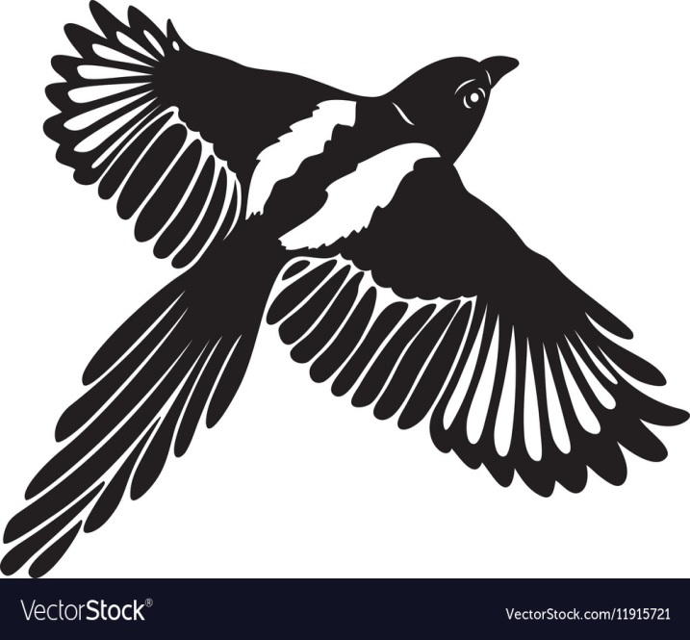
Conditons of play
- Nomination List on Club Notice Board
- Any Combination of Mixed Gender
- Club Uniform to be worn
- Major & Plate
- Qualifing games 15 ends
- Finals 21 ends
- Maximum 2 games to be played each day
- Dead ends to be replayed
- In the event of a tie extra end to be played
- 2 End rollup for the first game of days play only
Conditions of play may be altered by the Match Committee

